**SARAI KNOWLEDGE PORTAL**

**PESTS AND DISEASES OF CORN**

**Major Insect Pests of Corn**

1. **Corn Seedling Maggot *Atherigona oryzae* Malloch**

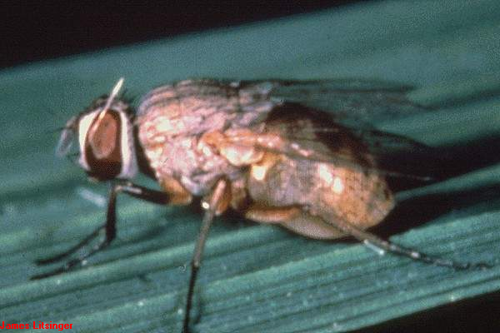

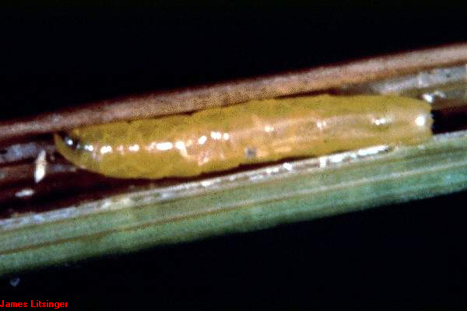

Destructive Stage

* Larval stage

Plant Part and Growth Stage Damaged

* Leaves of seedlings from emergence to early whorl stage (5-18 DAP).

Nature of Damage

* Larvae feed on young leaves therefore, lesions and curling are apparent.
* Severe damage will affect growth of plant and thus yield.

Management Practices

* Sow early or very late in the growing season.
* Synchronous planting.
* Remove alternate hosts (timely weed control).
* Apply fertilizer to invigorate formation of new shoots.
* Apply recommended insecticide.

Environmental Factors

* Growth is favoured by high humidity.
* Severe during wet season in some areas in the south.

1. **White Grub (June beetle) *Leucopholis irrorata* Chev.**

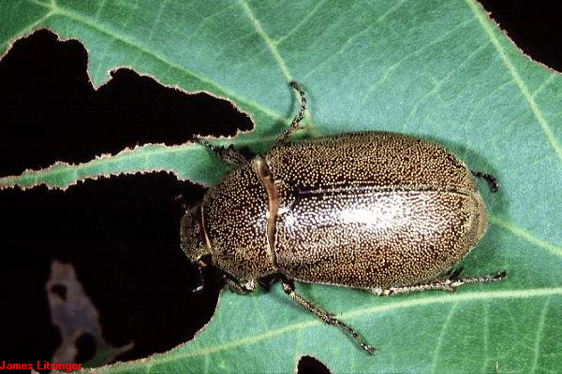

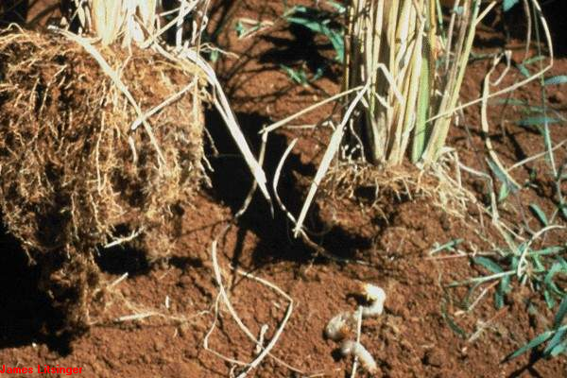

Destructive Stage

* Larval stage

Plant Part and Growth Stage Damaged

* Feeds on roots from emergence to early whorl (5 to 18 DAP)

Nature of Damage

* Stunted growth and yellowing of leaves because of root damage.

Management Practices

* Cultural: deep plowing, flooding of field 3-5 days before thorough land preparation.
* Apply recommended insecticides.

Environmental Factors

* Onset of wet season favours oviposition.

1. **Corn Semi-Looper *Chrysodeixis chalcites* Esper**

Destructive Stage

* Larval stage

Plant Part and Growth Stage Damaged

* Leaves and silk from first leaf to silking stage (8 to 58 DAP).

Nature of Damage

* Long abrasions on leaves caused by larval feeding.
* Cut silks.

Management Practices

* Plant resistant hybrids (BT)
* Synchronized planting
* Collection and destruction of larvae
* Apply recommended insecticides

Environmental Factors

1. **Common Cutworm *Spodoptera litura* Fab.**

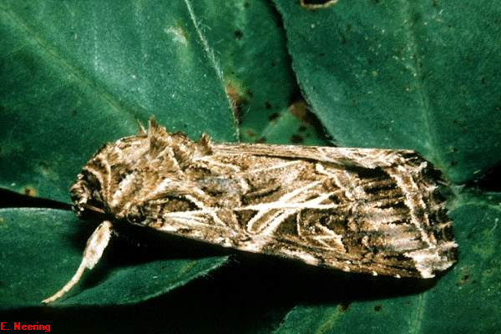

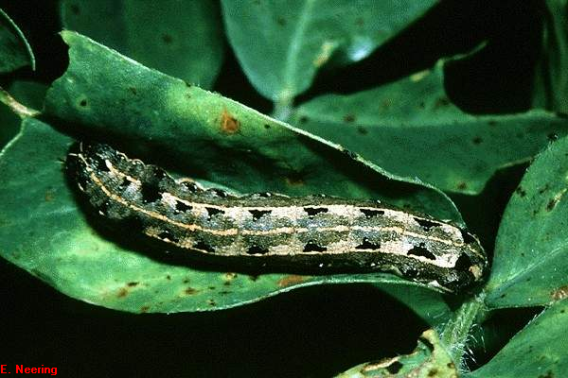

Destructive Stage

* Larval stage

Plant Part and Growth Stage Damaged

* Leaves of seedlings from emergence to early whorl stage (5-18 DAP).

Nature of Damage

* Young (soft) leaves scraped by young larvae. Grown larvae cut older leaves, midribs and stems.
* Complete defoliation of young plants

Management Practices

* Remove alternate hosts (timely weed control).
* Apply recommended insecticides
* Use of biological control agent Spodoptera *litura* nucleopolyhedrosis virus

Environmental Factors

* Drought followed by heavy rains may cause outbreaks

1. **True Armyworm *Mythimna separata***

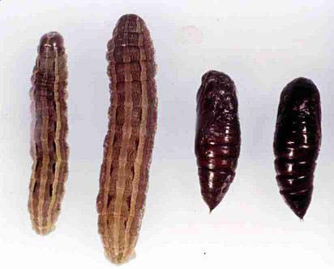

Destructive Stage

* Larval stage

Plant Part and Growth Stage Damaged

* Leaves, tassels and silk from late whorl to grain filling (32 to 80 DAP)

Nature of Damage

* Feeds on leaves and growing points. Damage on leaves are elongated but irregularly formed from the edges to right before the midrib.
* May affect the size of the ears and grain development.

Management Practices

* Maintain weed-free field.
* Collect and destroy egg masses and larvae.
* Apply recommended insecticides.

Environmental Factors

* Drought followed by heavy rains may cause outbreaks.

1. **Asian Corn Borer (ACB) *Ostrinia furnacalis* Guenee**

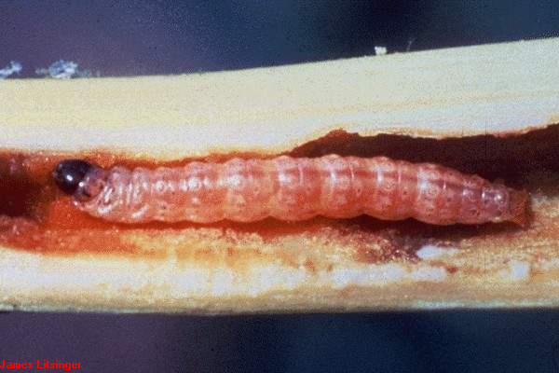

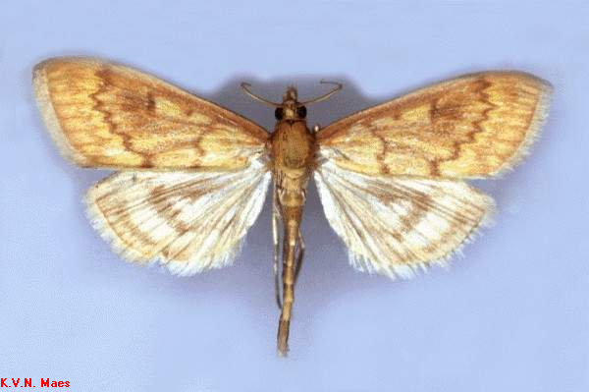

Destructive Stage

* Larval stage

Plant Part and Growth Stage Damaged

* Leaves, leaf sheaths, tassels, ears.
* ACB causes damage from seedling to maturity stages (13 to 110 DAP).

Nature of Damage

* Larval feeding cause holes and elongated lesions on leaves and leaf sheaths. They also cause clumped and/or broken tassels. The final instar bore through ears and stems to pupate.

Management Practices

* Synchronous planting
* Plant Bt hybrids
* Release biological control agent Trichogramma parasitoid
* Detassel 75% of the plants in the field 1-2 days after tassel emergence
* Timely weed control
* Apply recommended insecticides

1. **Corn Earworm *Helicoverpa armigera* Hubner**

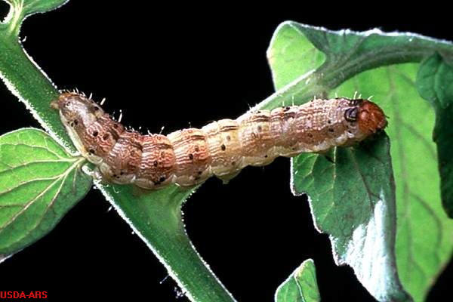

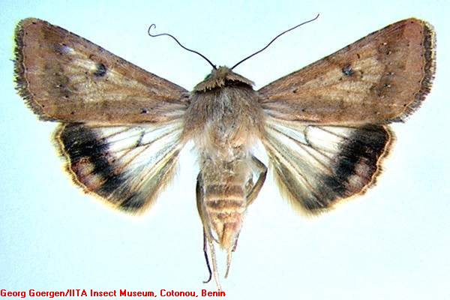

Destructive Stage

* Larval stage

Plant Part and Growth Stage Damaged

* Feeds on leaves from early whorl to hard dough stages(17 to 100 DAP)
* Also consumes emerging tassels and the tip of a developing ear and kernels.

Nature of Damage

* First two instars bore through the whorl which causes shotholes apparent at leaf unfolding.
* More mature larvae cause irregularly patterned holes on leaves

Management Practices

* Planting resistant varieties or hybrids
* Use of Trichogramma egg parasitoid
* Application of recommended insecticides

Environmental Factors

1. **Corn Leaf Aphid *Rhopalosiphum maidis* Fitch**

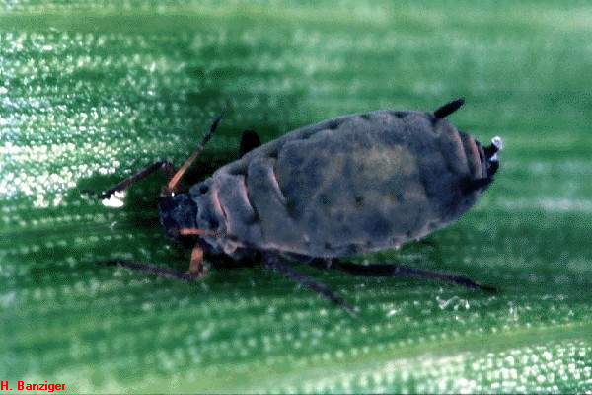

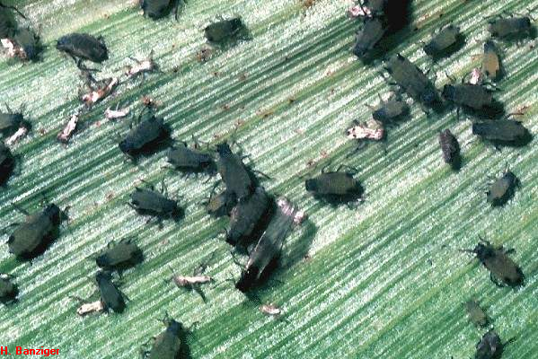

Destructive Stage

* Nymph and adult stages

Plant Part and Growth Stage Damaged

* Early whorl to post silking (17 to 60 DAP)

Nature of Damage

* Colonies are formed on the leaves which may cause seedlings to wither and die.
* Aphids suck plant sap that can cause yellowish mottling and stunting.
* Appearance of sooty molds.
* Transmits maize dwarf mosaic virus and sugarcane mosaic virus

Management Practices

* Planting of resistant varieties.
* Early sowing.
* Release of biological control agents: braconid flies, coccinellid beetles, lacewings.
* Application of recommended insecticides

Environmental Factors

* Warm temperature favours development of aphids.

1. **Corn Plant Hopper (CPH) *Stenocranus pacficus* Kirkaldy**

Destructive Stage

* Nymph and adult stage

Plant Part and Growth Stage Damaged

* Leaves and leaf sheaths from seedling to late whorl stages (11 to 40 DAP).

Nature of Damage

* Plant sap is sucked causing stunted growth of the plant.
* Plant secretions or honeydew harbour black sooty moulds which subsequently cause the leaves to dry.
* Vector of maize stripe or maize mosaic virus

Management Practices

* Treat seeds with recommended insecticides
* Fallow period of 2-3 months
* Release biological control agents
* Spraying of recommended insecticides

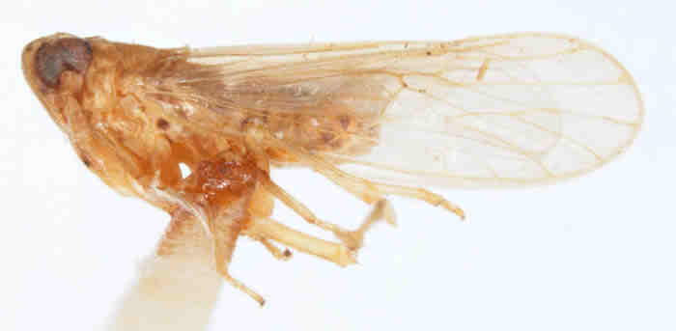

http://ag.udel.edu/research/delphacid/sp 1

**Common Corn Diseases**

**Fungal Diseases**

1. **Downy Mildew (Cause: *Peronosclerospora philippinensis*)**

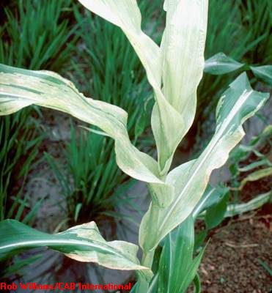

Symptoms

* Base of lower leaves have streaks or chlorotic areas where downy growth can be observed early in the morning. Next leaves exhibit more severe symptoms.

Disease Cycle

* Seedlings and young plants are infected by other crops and weed species around the corn field. Transmitted from the soil to the seeds or from the leaves by wind.

Control

* Reduce nitrogen fertilizer
* Plant resistant varieties.
* Eliminate infected plants.
* Maintain weed-free field.
* Use recommended fungicide.

1. **Leaf Blight (Cause: *Helminthosporium maydis,Bipolaris maydis*)**

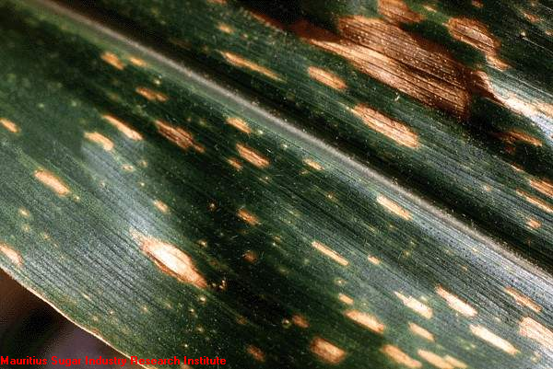

Symptoms

* Lesions on leaves varies in shape and size: elongated or oval tan to bown spots which may merge and develop to burning of large areas of the leaves.

Disease Cycle

* Spores are transmitted by wind from other infected crops or crop remains.
* High relative humidity favours disease development.

Control

* Planting of resistant varieties.
* Application of recommended fungicides.

1. **Corn Rust (*Puccinia polysora*)**

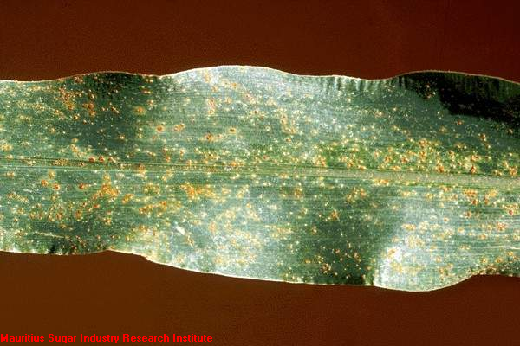

Symptoms

* Surfaces of leaf blades, leaf sheaths and stalks exhibit brown, circular, powdery pustules.
* Leaves which are severely infected dries up and defoliates prematurely.

Disease Cycle

* Air

Control

* Plow deep to bury scleotia

1. **Banded Leaf and Sheath Blight (*Rhizoctonia solani*)**

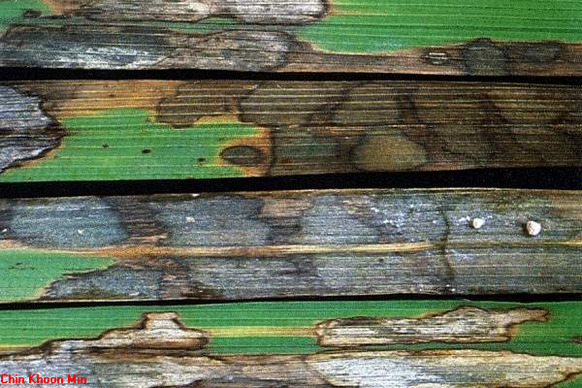

Symptoms

* Alternating bands of irregular blotches on the leafsheath, leaf blade and ear husks starting from the base upward.
* Blotches are grayish-green, with bluish gray or traw colored centers with distinct brown borders.
* Presence of irregular, white turning light to dark brown sclerotia on the dead ares is the most reliable sign of the disease
* Infected ears may be rotten often showing some seed germination at the base of the cob.

Disease Cycle

* The fungus survives on corn debris as mycelium and in soil as sclerotia
* Many plant species serve as alternate host
* Disease development is favoured by moist environment, especially during prolonged rainy periods

Control

* Practice deep plowing to bury sclerotia
* Avoid planting cultivars with very low ear placement
* Remove leaf sheath above the infected portion below the earshot
* Apply recommended fungicides

1. **Grey Leaf Spot (*Cercospora zeae-maydis*)**

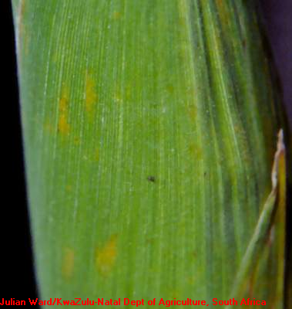

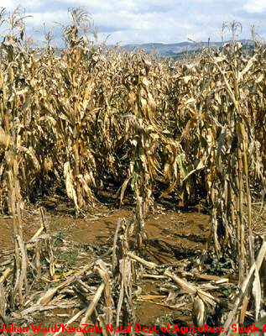

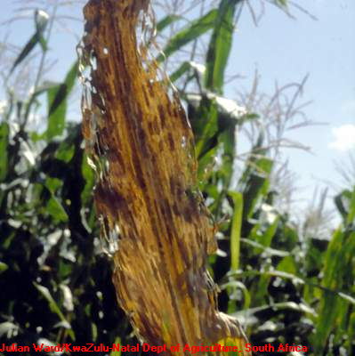

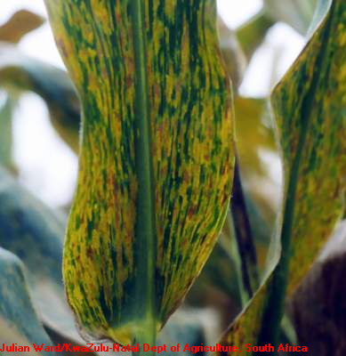

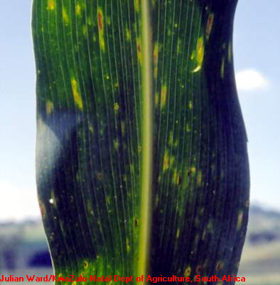

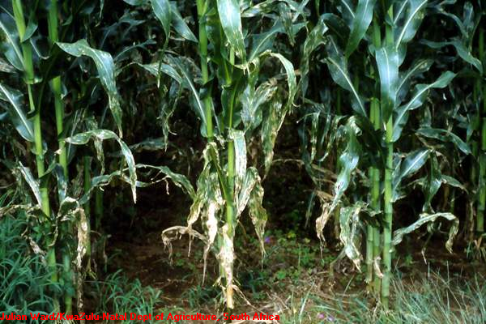

Symptoms

* Tiny spots surrounded by a yellow halo, which develop into distncly rectangular lesions delineated by the veins on both sides which run in parallel

Disease Cycle

* Inoculum starts from the surfaces of infested leaves.
* High RH (90-98%) and temperature between 22° and 30° C favour disease development.

Control

* Plant resistant varieties
* Apply recommended fungicide

1. **Corn Smut (*Ustilago maydis*)**

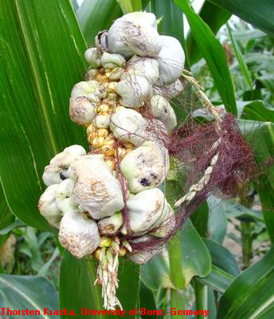

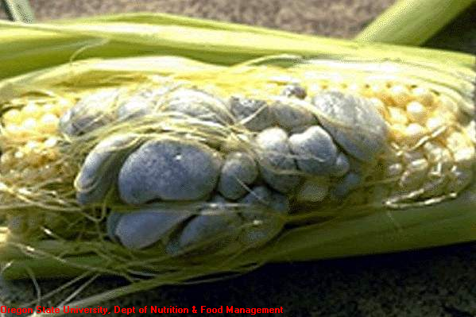

Symptoms

* Galls form on all above-ground parts of the corn plant, shiny, greenish-white which subsequently turns black due to the masses of powdery spores.

Disease Cycle

* Spores germinate to produce sporidia under dry condition and favorable temperature.
* Transmitted by wind and splashed water to young, developing tissues of corn.
* High nitrogen in soil favors disease development.

Control

* Use of resistant varieties.
* Avoid mechanical injury of plants
* Proper nutritional management

**Bacterial Disease**

1. **Stalk Rot (*Erwinia chrysanthemi* p.v. zeae)**
2. 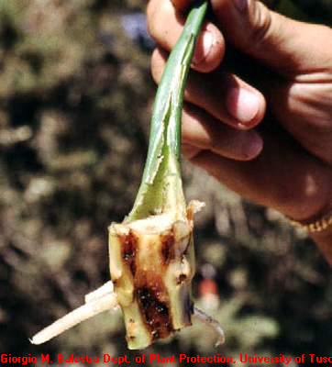

Symptoms

* Soft and mushy tissues that emit foul odor
* Wilted leaves

Control

* Cultivate to improve soil condition.
* Proper nutritional management

References:

Crop Protection Compendium 2005 Edition. CAB International.

Maize Pest Manual Third Edition. Pioneer Hi-Bred Philippines, Inc. 2008.